Program Information | [Lesson Title]  How Does That Work? |  |  |  |  |  | TEACHER NAME  Paula Mullet |  |  |  | PROGRAM NAME  Cuyahoga Community College
Program Information | [Unit Title]  Operations and Algebraic Thinking |  |  |  |  |  | NRS EFL  3 |  |  |  | TIME FRAME  180 minutes
Instruction | OBR ABE/ASE Standards – Mathematics
Instruction | Numbers (N) |  |  |  | Algebra (A) |  |  | Geometry (G) |  |  |  | Data (D)
Instruction | Numbers and Operation |  |  | N.3.8  N.3.11 | Operations and Algebraic Thinking |  |  | Geometric Shapes and Figures |  |  |  | Measurement and Data
Instruction | The Number System |  |  |  | Expressions and Equations | A.3.9  A.3.10  A.3.11  A.3.13 |  | Congruence |  |  |  | Statistics and Probability
Instruction | Ratios and Proportional Relationships |  |  |  | Functions |  |  | Similarity, Right Triangles. And Trigonometry
Instruction | Number and Quantity |  |  |  |  |  |  | Geometric Measurement and Dimensions
Instruction |  |  |  |  |  |  |  | Modeling with Geometry
Instruction | Mathematical Practices (MP)
Instruction | X | Make sense of problems and persevere in solving them. (MP.1) |  |  |  |  |  |  | Use appropriate tools strategically. (MP.5)
Instruction | X | Reason abstractly and quantitatively. (MP.2) |  |  |  |  |  | X | Attend to precision. (MP.6)
Instruction |  |  | Construct viable arguments and critique the reasoning of others. (MP.3) |  |  |  |  | X | Look for and make use of structure. (MP.7)
Instruction |  |  | Model with mathematics. (MP.4) |  |  |  |  |  | Look for and express regularity in repeated reasoning. (MP.8)

 | LEARNER OUTCOME(S)  - Write expressions that record operations with numbers and with letters standing for numbers.  - Apply the properties of operations to generate equivalent expressions.  - Identify when two expressions are equivalent.  - Use variables to represent numbers and write expressions when solving a real-world or mathematical problem. | ASSESSMENT TOOLS/METHODS  - Think of a Number *2-5 as formative assessment (student’s choice of any two to explain reasoning)  - Think of a Number *6 as the summative assessment
LEARNER PRIOR KNOWLEDGE

- Basic understanding of variables – that a number can be represented by a letter.

 | INSTRUCTIONAL ACTIVITIES  - Discuss with students their experiences with e-mails. Ask if anyone has received an e-mail where they say they can tell you your age by how many times you would like to eat out in a week or how many times you’d like to eat chocolate? The e-mail will ask you to answer questions and complete a number of operations as you scroll down the screen.  - Select one of the Think of a Number Email handouts based on the level of your class. Read the problem aloud as students calculate the whole number operations to figure out the number. When all the students have completed the computation individually or in pairs and come up with an answer to the problem, write the answers on the board. How do the answers compare? Are they the same (most will be) or similar? Ask the class how they think these problems work? Explain to the students that these “think of a number” type problems are based on mathematics.  - Explain to the students that the answers to this type of problem can be understood mathematically by generalizing the operations. The teacher will use a Think Aloud teaching strategy to demonstrate how she arrived at the answer in the previous problem. Use a variable for the number you pick then complete the various operations on your variable x. Be sure you discuss how each step could be expressed and then simplified along the way. Model additional examples, if desired, from the handout and then distribute the process for students to have as a reference. The discussion with the students is the most important part of this lesson. Go slowly! Be sure to discuss how the algebra proves the answer.  Teacher Note If you would like more information about algebraic thinking, please refer to the Teaching Algebraic Thinking Skills Teacher Resource handout provided. Be sure the students understand that algebraic expressions are simply ways to express variables and symbols such as a sentence uses words.  - Handouts Think of a Number *2 – Think of a Number *5 each contain a “think-of-a-number” problem. Let the students, either alone or with a partner, select a problem to solve. They should use several different numbers to prove that the answer will always come out the same. Finally write the problem algebraically using a variable and simplify the expressions.  Sample Answer/Response to Handout 2  Step 1: x + 4  Step 2: 3(x + 4) = 3x + 12  Step 3: 3x + 12 – 9 = 3x +3  Step 4: 2(3x + 3) = 6x + 6  Step 5: (6x + 6) / 6 = x + 1  Step 6: x + 1 – x = 1  Answers:  - Think of a Number *2 handout - Your answer will be 1. Explain why.  - Think of a Number *3 handout - Will you always get your original number? Explain why.  - Think of a Number *4 handout - Your answer will be 18. Explain why.  - Think of a Number *5 handout - Your answer will always be 5. Explain why.  Ask students to write an explanation of why two "Think of a Number" activities of their choice work. They should be sure to show the algebraic expressions and simplification work to explain their reasoning.  Your Age by Eating Out handout or Your Age by Chocolate handout are also more difficult problems and the teacher can use the Think-Aloud teaching strategy with students.  Teacher Note The numbers in Your Age by Eating Out and Your Age by Chocolate can be adjusted for additional calendar years. For example, for 2016, the numbers would be 1766 and 1765. These activities involve the same mathematics.  - Calendar Algebra handout is a slightly different and more difficult problem and should be used as a class activity. Let students do the calculations on a 3x3 array and then solve the equation together as a think-aloud. Calendar Algebra answer - Can you show that no matter what the 3x3 array of numbers, the answer will always be 9?  Guess a Birthday handout gives students an opportunity to write an expression with two variables and provides another opportunity for the teacher to use Think-Aloud.  - Distribute Think of A Number *6 for an assessment. Remind the students that the problem can always be proven using algebra.  For example, in this handout the math could be rewritten as follows when the number selected is x.  2x  2x + 6  (2x + 6)/2 = x + 3  x + 3 - x = 3  Have students write the algebraic expressions for each step and explain how the answer to the worksheet will always be 3 no matter what number is originally selected. |  | RESOURCES  Chalk board, white board or flip chart  Think of a Number Email handouts (attached)  Think Alouds [PDF file]. (n.d.). Retrieved from http://literacy.kent.edu/eureka/strategies/think_aloud.pdf  Teaching Algebraic Thinking Skills Teacher Resource handout (attached)  Student copies of Think of a Number *2 handout (attached)  Student copies of Think of a Number *3 handout (attached)  Student copies of Think of a Number *4 handout (attached)  Student copies of Think of a Number *5 handout (attached)  Student copies of Your Age by Eating Out handout (attached)  Student copies of Your Age by Chocolate handout (attached)  Student copies of Calendar Algebra handout (attached)  Student copies of Guess a Birthday handout (attached)  Student copies of Think of a Number *6 handout (attached)  Go on...think of a number, any number*. (n.d.). Retrieved from http://thinkofanumber.net/  Ohio Mathematics Learning Conductor Lessons Aligned to Ohio's Academic Content Standards. (n.d.). Retrieved from http://www.ohiorc.org/for/math/learningconductor/lessons.aspx  How Does That Work Learning Objects handout (attached)
DIFFERENTIATION

- Vary the difficulty of the Think of a Number situations used, depending on the students.
- Students can choose which two Think of a Number activities to explain their reasoning.
- Have students work in pairs initially to encourage lower-level students.
- Support student understanding with the "think-aloud” teaching strategy.

Reflection | TEACHER REFLECTION/LESSON EVALUATION
Reflection | ADDITIONAL INFORMATION  Search the web for more "think of a number" problems. Encourage students to write their own "think of a number" problems. The Lessons from the Learning Conductor offers many valuable lessons on Patterns, Functions and Algebra. You must register to use the site, although it is free for anyone in Ohio. How Does That Work Learning Objects handout will give students additional practice with algebraic expressions.

Teaching Algebraic Thinking Skills
Teacher Resource

Have you ever heard your students say, “Why do I have to learn algebra?” This is a great question that deserves an answer. Algebra is one of the cornerstones of today’s technology boom. Without algebra we wouldn’t have TV, radio, telephone, microwave ovens or other gadgets that make our modern world so comfortable and interesting.

Algebra is fundamental to understanding mathematical thought. It encompasses an understanding of patterns and functions, ways of representing and analyzing mathematical structures and situations, models that represent quantitative ideas and relationship and approaches that analyze change in a variety of situations. Most people recognize that algebra is needed by scientists or engineers, but algebraic thinking and reasoning are also used by many professions, including health care providers, graphic designers and home builders.

Algebraic thinking or algebraic reasoning involves forming generalizations from experiences with number and computation, formalizing these ideas with the use of a meaningful symbol system, and exploring the concepts of pattern and function.

But this is not the algebra you most likely experienced in high school. The focus now is on the type of thinking and reasoning that prepares students to think mathematically across all areas of mathematics. Being expected to teach algebra – at any level – can arouse anxiety. However, research support that algebraic thinking is necessary for today’s workforce. Blanton and Kaput (2003) state that teachers must find ways to support algebraic thinking and create a classroom culture that values “students modeling, exploring, arguing, predicting, conjecturing, and testing their ideas, as well as practicing computational skills.” Think about how to ‘algebrafy’ current curriculum by transforming existing activities and word problems from a single numerical answer to opportunities to discover patterns and make generalizations about mathematical facts and relationships. Encourage students to discuss why they believe a statement or solution to a problem is correct. Use the following prompts as ways to extend student thinking:
Tell me what you were thinking.
Could you solve this in a different way?
How do you know that is true?
Does that always work?

This type of relational thinking is crucial for students in the GED classroom, as well as for adults in the workplace. Research supports that without instruction, students bypass problem representation and try to just solve the problem. But before beginning the process of teaching algebra, teachers should be sure that students understand the basics. The key prerequisites for students to be successful in the study of algebra are to first understand the technical language of algebra; concept of variables; and concept of relations and functions.

When teaching algebra, teachers need to use practical experiences that go beyond the mere computation required by equations. When developing practice activities in the algebra classroom, be sure to:
- Develop processes/procedures for students to use when approaching algebraic tasks
- Create authentic exercises that highlight the critical attributes related to the concept being taught
- Provide opportunities for students to verbalize the task and predict what type of answer is expected
- Offer opportunities for students to discuss and write responses to questions dealing with key concepts being learned
- Select authentic exercises that anticipate future skills to be learned
- Design authentic exercises that integrate a number of ideas to reinforce prior learning as well as current and future concepts

Here are a couple suggestions to start to get your students involved with algebraic thinking. Be sure to set up T-charts to help organize your results. Seeing the data in chart form can help students recognize the pattern that is occurring. Be sure to help them generalize their pattern as an equation

The Handshake Problem
How many handshakes will there be if each person in your group shakes the hand of every person once? Start with a group of three people, then increase the group size by one person each time. Students can share and discuss different solution strategies. Generalize the total number of handshakes for an arbitrary sized group.

The Table Problem
How many people can be seated at a table constructed on 2 square card tables pushed together on one side? Only one person can sit on a side. And no one straddles the legs of the table. Now push 3 card tables together to make one long table. How many people can be seated at this table? How many people could sit at a long table constructed of 10 card tables? How many could sit at a table made with “n” card tables?

A Visit to the County Fair
How much will it cost to ride the amusement rides at the county fair? It costs $5 to enter the fairgrounds. Amusement rides are $1.25 per ride. What is the total cost if a visitor rides 1 ride? 5 rides? 10 rides? What cost changes in the problem? What cost stays the same in the problem? If you want to spend no more than $20, how many rides can you ride? Are there other costs that influence your cost for a day at the fair?

Blanton, M. L. & Kaput, J. J. (October 2003). Developing Elementary Teachers’ “Algebra Eyes and Ears”. Teaching Children Mathematics, (10)2, 70-77.

Teaching Algebraic Thinking Skills Teacher Resource

Think of a Number Email Handout

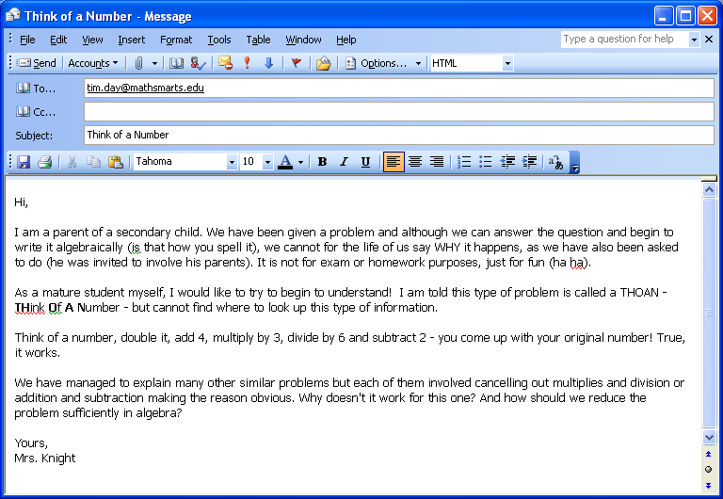

Think of a Number Email Handout

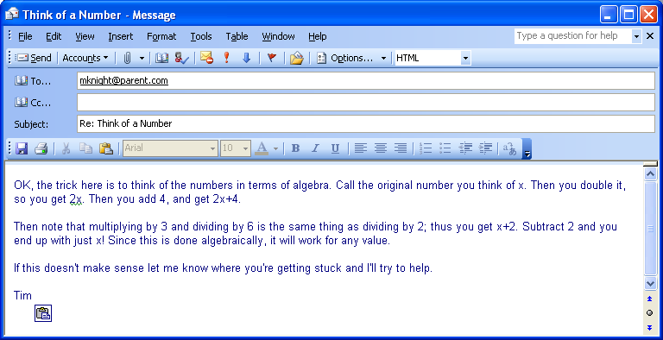

Think of a Number Email Handout

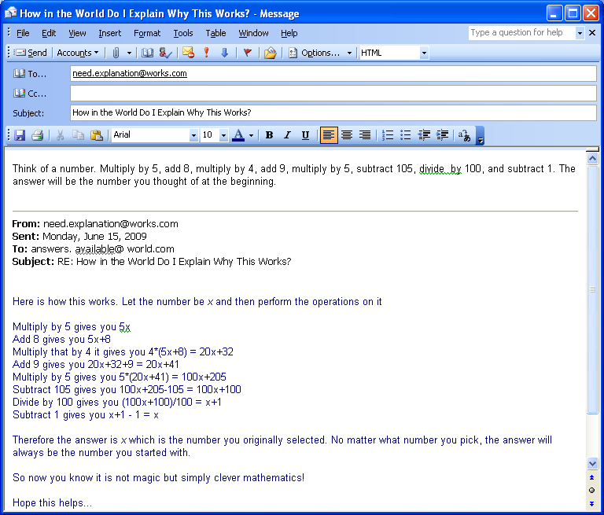

Think of a Number *2

Think of a number.

Add 4.

Multiply by 3.

Subtract 9.

Multiply by 2.

Divide by 6.

Subtract the original number.

What answer did you get?

Think of a Number *3

Think of a number.

Add 1.

Multiply by 9.

Add the original number.

Subtract 4.

Delete the ones digit.

What number do you obtain?

Think of a Number *4

Think of a number.

Add 7 to it.

Subtract 2.

Subtract your original number.

Multiply by 4.

Subtract 2.

What is your number?

Think of a Number *5

Think of a number between 1 and 25.

Double the number.

Add 10.

Divide by 2.

Subtract the original number.

What is the number?

Calendar Algebra

Use a calendar.

Select a 3x3 array of number from a calendar (any month, any year).

Add up the nine numbers (dates) in the array.

Divide the sum by the central number.

What number do you obtain?

Guess a Birthday

Give the following instructions to a friend:

1. Think of 2 numbers
(1) the number of the month in which you were born
(2) the number of the day of the month on which you were born
2. Multiply the month number by 5
3. Add 6
4. Multiply by 4
5. Add 9
6. Multiply by 5
7. Add the number of the day of the month on which you were born
8. Now get your friend's final answer:
Subtract 165 to reveal the month and day your friend was born.
The last two digits give the number of the day, and the other digits give the month.

Your Age by Eating Out

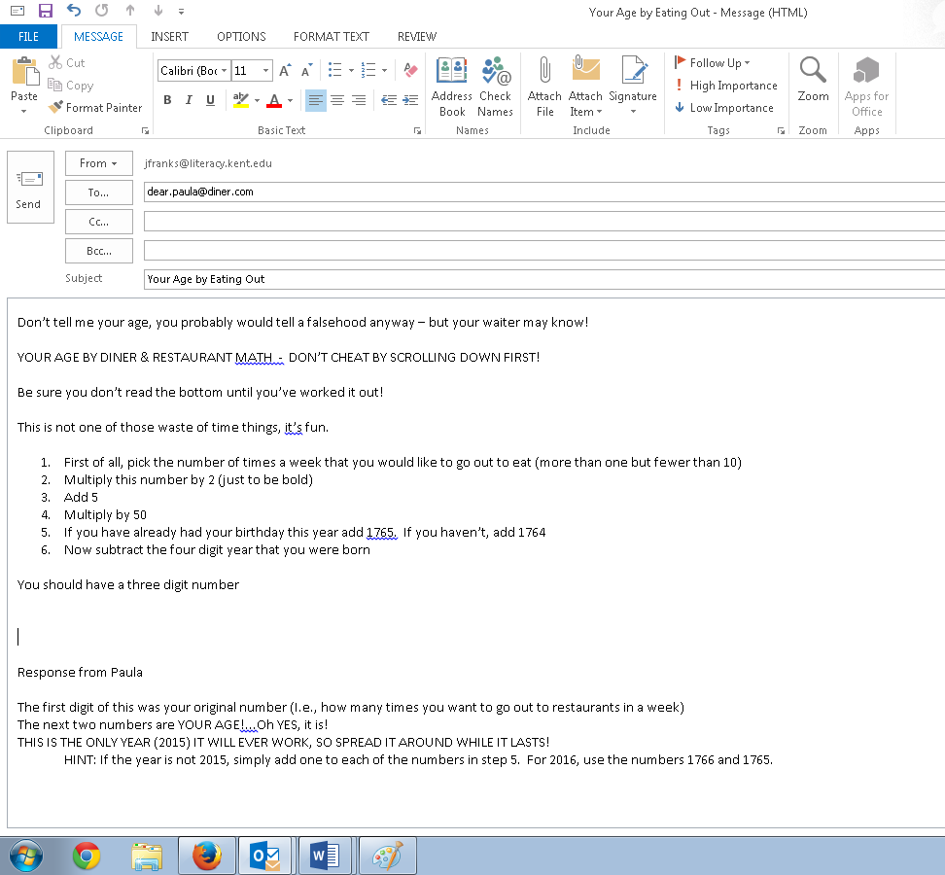

Your Age by Eating Out Handout
YOUR AGE BY CHOCOLATE
Don't tell me your age; you’d probably lie anyway

-- but the Hershey Man will know!

DON'T CHEAT BY SCROLLING DOWN FIRST!
It takes less than a minute. Work this out as you read.

Be sure you don't read the next page until you've worked it out! This is not one of those waste of time things, it's fun.
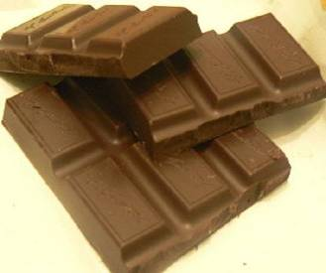

- First of all, pick the number of times a week that you would like to have chocolate (more than once but less than 10).
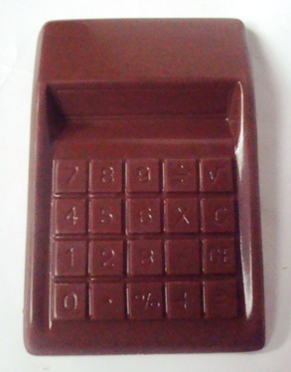
- Multiply this number by 2 (just to be bold).

- Add 5.

- Multiply it by 50 -- I'll wait while you get the calculator.

- If you have already had your birthday this year add 1765.
If you haven't, add 1764.

- Now subtract the four digit year that you were born.
You should have a three digit number.
The first digit of this was your original number
(i.e., how many times you want to have chocolate each week).
The next two numbers are


YOUR AGE! (Oh YES, it is!!!!!)

THIS IS THE ONLY YEAR (2015) IT WILL EVER WORK, SO SPREAD IT AROUND WHILE IT LASTS.



Your Age by Chocolate
Think of a Number *6

Step 1. Think of a number
Step 2. Double your number
Step 3. Add 6
Step 4. Divide by 2
Step 5. Subtract your original number

Questions

1. What is your answer to the puzzle?

2. Write each expression after each step. Be sure to show the simplification.

3. Explain how this puzzle works.



http://www.wisconline.org

Simplifying Algebraic Expressions: Addition & Subtraction
Author: Douglas Jensen & Allen Reed
School: Northeast Wisconsin Technical College
Description: Learners read definitions of the terminology associated with algebraic operations and then follow steps to simplify algebraic expressions.
http://www.wisc-online.com/objects/index_tj.asp?objID=GEM1804

Simplifying Algebraic Expressions: Division
Author: Douglas Jensen & Allen Reed
School: Northeast Wisconsin Technical College
Description: Learners read definitions of the terminology associated with algebraic operations and then follow steps to use the fundamental laws of division to simplify algebraic expressions.
http://www.wisc-online.com/objects/index_tj.asp?objID=GEM2104

Simplifying Algebraic Expressions: Multiplication
Author: Douglas Jensen & Allen Reed
School: Northeast Wisconsin Technical College
Description: Learners read definitions of the terminology associated with algebraic operations and then follow steps to use the fundamental laws of multiplication to simplify algebraic expressions.
http://www.wisc-online.com/objects/index_tj.asp?objID=GEM1904

An Introductory Algebraic Word Problem
Author: Kevin Ritzman
School: Fox Valley Technical College
Description: In this animated object, learners follow the steps for solving word problems using algebra. An introductory example is explained.
http://www.wisc-online.com/objects/index_tj.asp?objID=TMH5206

How Does That Work Learning Objects

